A Framework for Use with Racially and Culturally Integrated Families: The Cultural-Racial Identity Model as Applied to Transracial Adoption
Amanda L. Baden1 and Robbie J. Steward2
_______________________________________________________________________________________
A new model for understanding and depicting the unique identity experiences of those reared in racially and/or culturally integrated families is presented. The model accounts for heterogeneity within groups defined by their racially integrated families. For the purpose of describing and presenting the model, it was applied to the unique experiences of transracial adoptees. The model allows distinctions to be made between racial identity and cultural identity. These distinctions comprise 16 proposed identities of transracial adoptees and are made up of the degrees to which they have knowledge of, awareness of, competence within, and comfort with their own racial group’s culture, their parents’ racial group’s culture, and multiple cultures as well as the degree to which they are comfortable with their racial group membership and with those belonging to their own racial group, their parents’ racial group, and multiple racial groups. A model for understanding the role of parents, extended families, and social and environmental contexts was also presented as a guide for demonstrating the factors impacting the cultural-racial identities of transracial adoptees or others from racially and/or culturally integrated families.
_______________________________________________________________________________________

Introduction
The changing face of the American family necessitates that psychologists be prepared to work with families in which racial and cultural integration exist. Integrated families, or families in which greater than one racial and cultural heritage are represented, can be formed through transracial adoption, foster care, and interracial marriages, to name a few. When such integration occurs in families, the children raised in the families often become labeled as biracial children, transracial adoptees, and foster children. By the nature of the composition of their families, these children experience qualitatively different childhood experiences around the issues of race and culture. Thus, the racial and cultural identity formation processes for these children are different than for children raised in racially and culturally homogeneous families. As a result, children from these racially and culturally integrated families need helping professionals who are trained to meet the differing needs of these individuals.
Psychologists have recently begun to address the racially integrated family, but they are still in their infancy in their ability to accurately understand and identify the factors affecting members of racially integrated families. To better inform the practice of psychotherapy with these individuals, guidelines for addressing the effects of racial integration within families must be developed. With this goal in mind, the Cultural-Racial Identity Development Model (Steward & Baden, 1995) was developed. This model seeks to address the compelling roles of both race and culture within families where racial homogeneity does not necessarily exist. The Cultural-Racial Identity Model can serve as a framework for understanding and working with members of racially integrated families for two reasons. First, the model accounts for racial and cultural differences among parents and their children. Second, the model also takes into consideration the impact that the experiences and the attitudes of their parents, peers, extended family, social support networks, and the larger community have on the children. For these reasons, the Cultural-Racial Identity Development Model is both a comprehensive and current framework for use with racially integrated families. This paper will present and describe the Cultural-Racial Identity Model. To assist in the depiction of this model, one form of racially integrated families will be addressed: transracial adoption.
Transracial Adoption
Adoption, as traditionally practiced, was a way to pair children without families with married couples wanting children. Typically, Caucasian couples wanted to adopt healthy Caucasian babies. Thus, adoption originated as a means for providing children to “childless white couples” (McRoy, 1989, p. 147) and not as a means for caring for dependent children. After World War II, many European children had survived the war but their families had not (Kim, Hong, & Kim, 1979). To accommodate these children, adoption practices were expanded to include intercountry adoptions (i.e., adoptions of children born in countries other than the country of the adoptive parents). Subsequent international conflicts such as the Korean War and the Vietnam War also resulted in children needing families, so the first intercountry transracial adoptions were practiced. By the 1960s, contraception, legalized abortion, and increased social acceptance of single/unwed parenting decreased the number of available White infants for adoption. Also in the 1960s, domestic transracial adoptions (i.e., adoptions of children of different racial groups than the adoptive parents) within the United States became a relatively common phenomenon, and Caucasian couples began to adopt American racial minority children as well. In the early 1970s, transracial adoption was criticized for its potential damaging effects on children (National Association of Black Social Workers, 1972), and transracial adoption placements became much less frequent, especially domestic transracial adoptions. After a series of studies were conducted to disprove the criticisms of transracial adoptions, legislation was passed that allowed resurgence in transracial adoption placements (e.g., the Multi-Ethnic Placement Act of 1994). Today, transracial adoption has become an increasingly popular option for those wishing to adopt. As a result, both domestic (within the United States) and international (intercountry) transracial adoptions have received additional attention by both the media and professional adoption workers.
Many transracial adoptees have now grown into adulthood. However, helping professionals have yet to have reliable and consistent information regarding the most effective methods for treating transracial adoptees. Instead, the literature addressing transracial adoption to date has primarily been focused on proving or disproving the predictions of opponents to transracial adoption. Using this reactionary approach to research, scholars have focused on addressing criticisms of transracial adoption and on either affirming or negating these criticisms. That “goal” was essentially achieved because transracial adoptees were not found to be more psychologically maladjusted than those adopted into same-race households (e.g., Andujo, 1988; Barth, Berry, Yoshikami, Goodfield, & Carson, 1988; McRoy, Zurcher, Lauderdale, & Anderson, 1984; Silverman & Feigelman, 1981; Zastrow, 1977). Although this approach to research has been employed for the past three decades, questions about transracial adoptees’ identity development and the impact of transracial adoption on adoptees remain. To answer these questions, several areas require more attention from researchers.
First, because transracial adoption has been and continues to be practiced, professionals still need to determine what differences currently exist among transracial adoptees rather than just focusing on their differences from other groups. Over 30 years of research on transracial adoption has resulted in finding that the unique needs of transracial adoptees and those raised in racially integrated families have scarcely been addressed. A small number of studies attempting to make suggestions for the counseling/psychotherapeutic needs of transracial adoptees exists, but they barely begin to examine the salient issues for transracial adoptees. With few exceptions (e.g., Helwig & Ruthven, 1990; Hill & Peltzer, 1982; Myer & James, 1989; Rickard Liow, 1994; Rathbun & Kolodny, 1967), psychologists have yet to examine the needs of transracial adoptees. Perhaps this area of research has been neglected because of the assumption that the needs of transracial adoptees are similar to the needs of traditionally (intraracially) adopted children. To endorse this assumption, however, a crucial factor in development and adjustment is ignored: the racial and cultural identity development of transracial adoptees. In the case of transracial adoptees, the racial group membership of the adoptees differs from their adoptive parents’ racial group membership and in many instances, the culture of the adoptees also differs (e.g., as in intercountry adoptions). Opponents to transracial adoption predicted that these differences would have a differential and potentially negative effect on transracial adoptees—an effect that children adopted intraracially do not experience. However, this expectation of differential experiences for transracially adopted children necessitates that psychologists be prepared to serve the needs of these individuals throughout their childhood and adulthood. Moreover, the implications for the practice of counseling with these individuals must be determined.
Second, further research should be conducted regarding the identity of transracial adoptees and those factors that contribute to their identity. To date, the primary focus in transracial adoption studies and literature has been the racial differences between parents and children. In doing so, these studies have overlooked the impact of the family and the characteristics of parents that are independent of their racial group membership, thereby under-representing the role of the adoptive parents in the psychological adjustment and the racial identity of the children. As a result of this oversight, many studies of transracial adoptees have been based on the assumption that racial differences between parents and children cause psychological maladjustment and “poor” identity development rather than on the probability that parenting skills, parental attitudes, environmental attitudes, and so forth, are likely to have as great an effect, if not a greater effect, on transracial adoptees’ adjustment.
Third, future research on transracial adoption would benefit from examining a common assumption reflected in the literature on transracial adoption—the assumption of homogeneity among transracial adoptees. That is, as with members of any identifiable group, observers tend to assume greater betweengroup variance and may neglect to account for within-group differences. The authors’ model for conceptualizing the identities of transracial adoptees both allows for and expects differences among or within transracial adoptees as a group. All transracial adoptees may not have a “positive” racial/ethnic identity nor will all transracial adoptees experience identity confusion to such a degree that it could be classified as “maladjustment.” In essence, what the present authors suggest is that all transracial adoptees identify with a culture or cultures and with a racial group or racial groups, but they do not necessarily all identify with the same culture(s) or racial group(s) because differences exist within the population of transracial adoptees.
Fourth, studies of transracial adoption have all used somewhat different definitions of racial identity when examining the experiences of transracial adoptees. Frequently, studies purporting to examine racial identity tended to investigate only the racial group preferences and objective racial self-identification of transracial adoptees and not their racial identity development (e.g., Shireman & Johnson, 1986; McRoy et al., 1984). These studies conceptualized racial identity as being the racial group (e.g., Black, White, Korean, Native American, etc.) to which the adoptees felt they belonged. This conceptualization of racial identity appears to be based on the acknowledgment or recognition of racial group membership rather than on feelings about, attitudes toward, knowledge of, competence within, or comfort with one’s racial group. Thus, these other conceptualizations of racial identity may actually contain information about the identities sanctioned by society rather than the actual identities of transracial adoptees.
To implement these suggestions for future research on transracial adoption, a guideline for observing and systematizing the study of transracial adoptees is needed. As stated above, one such guideline, the Cultural-Racial Identity Model, was offered by Steward and Baden (1995). This model attempts to explain the variation in identity status of transracial adoptees. The identity statuses that Steward and Baden postulate differ from previous models of identity, racial identity, and ethnic identity because of their emphasis on examining the culture and the race of transracial adoptees separately. They believe that the separate examination of the cultural identity and the racial identity of transracial adoptees is necessary to fully depict transracial adoptees’ unique experiences in racially and possibly culturally integrated families. This model can serve as a starting point for extending the study of transracial adoption and its effects to another level of analysis.
Rationale for Developing the Model
Racial/ethnic identity has been the focus of much of the attention and criticisms of transracial adoption. The empirical literature addressing transracial adoption has primarily examined the effects transracial adoption has on the adoptees’ racial identity, self-esteem, and psychological adjustment. However, despite all the evidence showing similar levels of adjustment and self-esteem between transracial adoptees and intraracial adoptees (e.g., Andujo, 1988; Grow & Shapiro, 1974; McRoy, Zurcher, Lauderdale, & Anderson, 1982, 1984; Silverman & Feigelman, 1981; Simon & Alstein, 1977, 1981), the practice of transracial adoption continues to be debated and controversial. Steward and Baden (1995, 1997) viewed this controversy as resulting from a lack of theory conceptualizing the unique experiences of transracial adoptees. Furthermore, because of the racial differences between adoptive parents and the adoptees in transracial adoption, existing theories of racial/ethnic identity (e.g., Helms, 1990) are not applicable to the experiences of transracial adoptees.
Because the experiences of transracial adoptees may differ from that of intraracial (same-race) adoptees and of nonadopted individuals, several researchers and professionals in the field have also acknowledged a need to conceptualize the racial/ethnic identity of transracial adoptees. Tizard (1991) noted that the majority of studies on transracial adoptees do not examine the degree to which adoptees endorse a mixed cultural identity; rather, these studies tend to have transracial adoptees choose between their adopted and their birth identities. Researchers may fail to recognize this difficulty because, as Tizard further stated, immigrant children living with their birth parents in the United States have yet to be compared to transracial adoptees and this continues to be the case. Without such comparisons, a clear understanding regarding the degree to which “the identity conflicts of the intercountry adoptees stem from living in a white culture, rather than with white parents per se” (Tizard, 1991, p. 754) cannot be accurately understood.
Trolley (1994–1995) shared Tizard’s recommendation regarding the need for research assessing how international adoptees feel about their mixed heritage and how they choose to define their cultural identification. Trolley advocated the identification of variables “which promote pride in one’s native culture and how the benefits of both cultures can be integrated” (p. 261). Trolley also acknowledged visible racial differences between transracial adoptees and their adoptive parents as being likely to have an impact on their identity.
Similarities between biracial/interracial/multiracial individuals and transracial adoptees have occasionally been assumed by professionals in the field (Hill & Peltzer, 1982). The similarities in these individuals’ experiences may be assumed because both are reared with racial differences within the family. However, although parallels can be discerned between these groups, the present authors believe that the adoptive experience of transracial adoptees can both complicate and qualitatively alter the experiences of transracial adoptees. Furthermore, although the Cultural-Racial Identity Model was developed with racially integrated families as the basis, the model can be used for any individual who has had the experience of being raised in areas where low levels of racial integration can affect his/her identity experience. For example, “displaced” children, or those who were raised by their biological parents in a community and school where the children are racial ethnic minorities, are likely to manifest cultural and racial identities that are similar to those for children raised in racially integrated families. In both situations, choices about racial and cultural affiliations are made and levels of exposure to differing cultures and races are likely to impact identity experiences. For all these groups, the Cultural-Racial Identity Model can serve as an effective means for guiding research on the identity experiences of biracial, interracial, multiracial, transracially adopted, and displaced individuals.
Several studies (e.g., McRoy et al., 1982, 1984; Zastrow, 1977) used samples of transracial adoptees who were biracial (i.e., had one Black birth parent and one White birth parent) but the researchers classified them as “Black.” However, Brown (1995) acknowledged that although biracial children have been categorized as Black within the official system of racial classification, conflicts can occur for these children because of “society’s insistence that interracial children are simply black, when in reality they incorporate a dual racial heritage” (p. 125). This societal perspective “undermines the formation of a healthy racial identity and creates conflicts” (p. 125). Moreover, an assumption in “popular opinion” is that those biracial or interracial individuals who have disassociated themselves from their White heritage and have accepted the socially endorsed Black identity have resolved their conflicts about racial identity and racial group membership (p. 126). Also popular is the belief that an interracial/mixed/dual identity is “evidence of defensive denial” because a White identity is regarded as “detrimental to the emotional health of interracial people since . . . it is an illegal identity for them” (p. 126).
Brown (1995) conducted a study of 119 biracial young adults between 18 and 35 years of age. Their racial identity was examined through a semi-structured interview and consisted of racial self-identification, how they viewed themselves racially in the absence of societal pressures, and racial self-perceptions during various developmental phases. They were also asked if they had ever tried or considered trying to “pass” as White. Conflict was also measured with respect to their racial identity. Findings indicated a nonlinear journey toward racial identity and that racial identity differed—some identified as Black and some as White, but most preferred an interracial identity if given the option. Of particular interest for the Cultural-Racial Identity Model (Steward & Baden, 1995) is the finding that biracial individuals have differing public and private identities. This compartmentalization frequently evolves as the result of individuals desiring to maintain their interracial self-perception while simultaneously attempting to adhere to social expectations that they ignore their White backgrounds (Brown, 1995). This conforming behavior was described by some as a coping mechanism that grew from their families’ conditioning and from the expectations of society as a whole (Brown, 1995), whereas others described it as a conscious and often sudden decision when their interracial or White self-perceptions were criticized.
Brown (1995) also found “fluctuations” in racial identity through different developmental phases with similar proportions of biracial individuals recalling identifying as Black, White, and “human.” Predictors of racial identity were cited as: (a) messages from family or friends regarding racial group membership; (b) acceptance by Blacks within their social networks; (c) racial status laws; (d) contact with various racial groups; (e) exposure to both Black and White cultures; and (f) physical appearance or phenotype. According to Brown, these results did not demonstrate that a Black identity is most successful for individuals from multiracial backgrounds, but the results did reflect the emotional costs of having a White identity. Specifically, she found that diminished conflict in identity was associated with interracial identity. Moreover, Brown found that contributing to conflicts in racial identity are societal pressure to identify as Black, the lack of institutional recognition of the interracial identity, and the reality that biracial individuals cannot legally identify as White.
In another study of interracial or “mixed parentage” individuals, Tizard and Phoenix (1994) interviewed 58 biracial (one Black and one White parent) adolescents between 15 and 16 years of age. They assessed the adolescents’ racial self-identification, attitudes toward their status as mixed parentage individuals, and their friendships and allegiances. Findings indicated 39% self-identified as Black, 10% identified as Black in certain situations, and 49% did not identify as Black. Instead, they self-described as “brown,” “half and half,” “mixed,” or “colored” and 10% stated they “sometimes felt White” (p. 1404). Positive attitudes about their mixed parentage were associated with attending a multiracial school but not with thinking of oneself as Black, living with a Black parent, being in certain social classes, or holding certain political views. “Problematic identities” were associated with a strong affiliation to White people and, interestingly, with reports that their parents had told them to be proud of being Black or of mixed heritage.
With respect to the allegiances (i.e., those they felt comfortable with) and friendships that the adolescents reported, two-thirds of the adolescents reported feeling equally comfortable with White and Black people and the majority of the remaining one-third reported feeling greater discomfort with Black people than with White people. More of the adolescents had a close White friend (85%) than a close Black friend (42%) with 27% having no Black friends. Finally, another interesting result was that those attending multiracial and state schools and those living with a White parent only were most strongly affiliated to Black people, whereas those attending predominantly White and independent schools and those living with a Black parent were most strongly affiliated to White people. Tizard and Phoenix (1994) critiqued the assumptions that mixed parentage individuals “need” to have a Black identity and that the race/color of foster or adoptive parents is “of paramount importance in the development of a positive racial identity” (p. 1409). These assumptions do not allow the individual construction of identity and deny these individuals’ mixed backgrounds. Furthermore, Tizard and Phoenix stated, “our findings suggest that during adolescence, school, social class, and peer groups exert more influence on racial identities than the color of their parents” (p. 1409).
The results of these two studies on biracial individuals serve as introductions to the theoretical underpinnings for the current model. Several of the same factors found to affect racial identity in the Brown (1995) and Tizard and Phoenix (1994) studies can be found in the description of the Cultural-Racial Identity Model (Steward & Baden, 1995).
Theoretical Bases for the Cultural-Racial Identity Model
Prior to developing the Cultural-Racial Identity Model, several existing theories of racial and ethnic identity were considered but eventually found to lack essential elements for their effective use with identity as experienced and formed in racially integrated families. Theories of racial identity, such as those offered by Cross (1971), Helms (1990), and Atkinson, Morten, and Sue (1989), do not account for racial heterogeneity within families. As a result, they do not truly depict the identity experiences of those raised in racially integrated families. However, theories of identity and racial identity have influenced the development of the Cultural-Racial Identity Model and will be reviewed.
Any theory or model of identity begins with the work of Erik Erikson (1980). His work provided the groundwork for Marcia’s identity statuses (1980) and the racial identity development models of Cross (1971) and Helms (1990). The construct of racial identity is based on the concept of personal identity as described by Erikson (Helms, 1990).
The development of identity has generally been associated with adolescence. In Erikson’s theory, this represents the fifth stage in which individuals, must negotiate the ego identity, versus identity diffusion crisis. Erikson (1968) believed that identity formation includes, as an influence on identity, the context and environment in which an individual matures. Erikson stated that traditional psychoanalytic theory has not incorporated identity as evidenced by the theory’s failure to conceptualize terms for the environment. Erikson also stated that identity must be integrated into culture so that a “unity of personal and cultural identity” can be formed (Erikson, 1968, 20). This inclusion of environment and culture into the theory set the stage for conceptualizing culture and race into identity formation, particularly for transracial adoptees.
Extending Erikson’s work, Marcia (1980) developed an identity status approach to study identity formation. Marcia included a focus on more of the conscious processes of identity formation as opposed to the unconscious processes delineated by Erikson (Brenner, 1993). The identity statuses were also intended to be outcomes of the process of identity formation and to be structural properties of the personality (Patterson, Sochting, & Marcia, 1992). Marcia’s work impacted the development of the Cultural-Racial Identity Model in several ways. His use of a graphic model where the presence or absence of an identity crisis and a commitment to an identity determined the identity status of the individual set the stage for constructing the Cultural-Racial Identity Model’s depiction of identity statuses.
Identity Formation in Adoptees
Although the theorists described above did not directly address the effects of adoption on identity, their theories have been extended and interpreted to account for the experiences of adoptees. Much of the work addressing identity in adoptees has focused on Eriksonian theory and on psychodynamic theories. The process of identity formation in adoptees was addressed by LeVine and Sallee (1990) in their paper describing “critical phases among adoptees.” They noted the additional emotional and behavioral stress imposed by adoption on adoptees’ psychological adjustment, but they also recognized the need to determine the degree to which the origins of problems experienced by adoptees are due to family dynamics as opposed to the adoption itself. Their review of the literature indicated a greater likelihood of adjustment difficulties if the adoptive parents are older at the time of adoption, if the adoptee is an only child in the adoptive family, if the parents or extended family do not support the adoption, and if conflicts generally exist within the family (p. 219).
LeVine and Sallee addressed adoption from a psychosocial and psychodynamic perspective. They described the basis of adoptees’ adjustment as centered around the adoptees’ process of “fully understand[ing] the implications of being adopted” (p. 221). They describe: (a) Phase I—preawareness; (b) Phase II—dim awareness of a special state; (c) Phase III—cognitive integration of biological and social differences; (d) Phase IV—identity crisis of the adopted adolescent; and (e) Phase V—concomitant acceptance of the biological and adoptive family. After the adoptees traverse the first three phases, they become aware of their adoptive status and reach a cognitive awareness of their unique biological and social status as adoptees. However, in Phase IV, the adoptees are often adolescents and must attempt to develop, according to Erikson (1968) “1) a conscious sense of their individual uniqueness; 2) an unconscious striving for continuity of experience; and 3) a solidarity with group ideals” (LeVine & Sallee, 1990, p. 223). Adoptees’ attempts at achieving continuity with their past and solidarity with the group are more difficult and their questions about their biological roots are most salient. These difficulties coupled with such early childhood traumas as abuse, neglect, and poor parental bonding may make adoptees more vulnerable to maladjustment, particularly in the form of narcissistic personality disorders. LeVine and Sallee also listed signs of maladjustment according to the phase of adjustment of the adoptees. Some examples are being unresponsive to adults, language deficits, rage, inappropriate affect, splitting, active rejecting of adoptive family, and emerging personality disorders.
Identity Formation in Racial Ethnic Minorities
As noted above, racial identity has previously been conceptualized as an individual’s objective racial self-identification and racial group preferences. Occasionally levels of acculturation and ethnic group pride have also been included. Since Cross developed one of the first models of racial identity development in 1971, several other theorists have extended his model or developed similar models for different populations. However, these more recent models share the premise that psychological adjustment and self-concept may, to a degree, depend upon the racial identity of the individual. Those in particular stages of development are believed to have poorer adjustment and poorer self-concepts. The parallel between this belief and that found in Erikson’s theory (1968) is evident.
Relationship Between Racial Identity and Eriksonian Theory
One of the most well-known theorists of racial identity development has been Helms (1990) who extended the work of Cross (1971) to aid in understanding the methods by which individuals identify with various racial groups. She conceptualized racial identity as comprising a combination of personal identity, reference group orientation, and ascribed identity. Helms described personal identity as the feelings and attitudes one has about oneself, reference group orientation as the degree to which particular racial groups are used by, and ascribed identity as one’s overt expressed affiliation to a particular racial group. Helms cited Erikson’s work in her identification of these components and noted the role that sociocultural influences are given in Erikson’s theory of adolescent identity development (1968). She suggested that at different stages or times in individuals’ lives, different individuals and institutions are influential in the development of racial identity. In individuals’ early childhood and infancy, parents and adult authority figures are most influential on racial identity whereas peers or cohort and nonfamilial social institutions (e.g., school, media) are more influential during late childhood and adolescence. However, as already noted, Helms’ model does not account for racial heterogeneity within families and their effects on the development of identity.
With the acknowledgment that culture and race affect individuals’ experiences and, therefore, development in many domains, the formation of identity in adolescents represents yet another affected area. Phinney and Rosenthal (1992) noted that for “adolescents from ethnic minority groups, the process of identity formation has an added dimension due to their exposure to alternative sources of identification, their own ethnic group and the mainstream or dominant culture” (p. 145). This process is likely to be even more complicated for transracial adoptees. Phinney and Rosenthal identified differences between the dominant culture and adolescents’ cultures of origin as primary factors in adolescents’ abilities to integrate ethnic identity into self-identity. They also posited that a positively valued ethnic identity is necessary for the construction of a positive and stable self-identity (as described by Erikson, 1968). However, as noted in the review of the study by Andujo (1988), the concept of a “positive ethnic identity” should be considered in greater depth because of the values and judgment inherent in the construct.
To better conceptualize the role of race and culture in identity formation, a distinction must also be made between ego or self-identity and ethnic identity. Phinney and Rosenthal (1992) described ethnic identity as a social identity with its meaning coming from the culture with which one is affiliated. They noted that despite the attention given context in Erikson’s (1968) theory, little research has actually examined the role of family in identity formation. Ethnic identity also involves the heritage that individuals are given rather than that which is chosen. The aspect of choice contrasts with Erikson’s work in which occupations or goals are chosen. A third distinction is the importance of ethnic identity among various ethnic groups. The salience of ethnic identity differs among ethnic groups and individuals whereas ego identity is considered to be more stable and similar for all adolescents. These distinctions demonstrate the importance of culture and race in identity formation as well as the differences that are inherent in the identity formation of racial ethnic minority adolescents.
Phinney and Rosenthal (1992) further noted that ethnic identity should also be compared with self-esteem because prior evidence has demonstrated that achieved ego identity is associated with high self-esteem. Their review of the literature suggested that “the consequences of minority group membership for an individual’s sense of self-worth are not due to minority status per se but are mediated by other factors such as gender role prescriptions in society” (p. 163). In particular, an achieved ethnic identity, which consists of the exploration of issues related to one’s ethnicity and the resolution of the issues and a commitment to an ethnic identity, contributed positively to self-esteem.
Also contributing to the understanding of identity formation in racial ethnic minorities is the work of Whaley (1993). He examined a construct termed cultural identity in relation to African American children and their identity formation. He defined cultural identity as similar to ethnic identity but including similarities in values, beliefs, and attitudes. Whaley reviewed the literature on cultural identity formation and found that for African American children, interactions among cultural factors, cognitive-developmental processes, and social experiences determine identity formation. African American children’s identity formation appears to be highly impacted by their cognitive-developmental processes. Whaley noted that young children (between ages 2 and 6) have not reached cognitive developmental stages at which they can accurately racially self-identify. Racial awareness and cultural identity increase with each successive stage in Piagetian cognitive-developmental theory. Ultimately, the importance of cultural identity in racial ethnic minority adolescents varies according to “the degree of identification with their ethnic/racial group, level of self-exploration and self-awareness, and cross-cultural social experiences” (p. 414).
Because Phinney and Rosenthal (1992), in addition to numerous other researchers, have attempted to demonstrate the link between “positive ethnic identity” and self-esteem, additional results of Whaley’s (1993) literature review are relevant. Whaley noted that the degree to which children are competent in areas they value and the level of regard or support they perceive from significant others impacts their self-esteem. Thus, personal efficacy, or competence, is also considered to be relevant to the identity formation of adolescents.
Identity Formation in Transracial Adoptees
One of the early attempts at understanding the identity experiences of transracial adoptees was offered by Falk (in Zastrow, 1977). He noted that no theoretical work in this area had yet been done, but despite the lack of formal theory, he anticipated the work of Steward and Baden (1995) and other researchers in the field.
Falk (in Zastrow, 1977) stated that Black children learn the special meanings and values of being Black in America through their birth parents and their community. When Black children are reared in White families, they also learn the values and meanings of their White middle-class families. Falk poignantly described two potential outcomes for transracial adoptees’ identity experiences. First, he noted that,
at some point the TRA [transracially adopted] child will cast off the protectiveness of the family of orientation and establish his more-or-less independent identity in the community of his choosing. If in this new circumstance he finds himself forced into situations where he is identified stereotypically and he is without prior experience in coping with them, he may face an identity crisis. . . . His identity will be with the white world while others assume that his identity is with the black world. His rearing establishes the white world as his referent, and his new peers demand that his referent be the minority world. (in Zastrow, 1977, p. 57)
Alternatively, he drew upon Erikson’s work and suggested that, given the necessary guidance and affection by adoptive parents, transracial adoptees could develop a positive self-concept and the social and interpersonal skills needed to successfully cope with the environment. Through exposure to the history and culture of the transracial adoptees’ race, they should be able to obtain more information regarding the meanings and values associated with their race.
In a recent book chapter, Richards (1994) addressed identity formation in transracial adoptees. He cited the popularity of Erikson’s concept of identity in examining issues of adjustment. However, Richards (1994) stated the importance of recognizing that although identity involves the appreciation and awareness of one’s difference from others, it also involves a sense of sameness, commonality with others, and identifying with larger groups or systems. He also advocated that distinctions be made between one’s personal identity and one’s social identity. The difference between these two aspects of identity are particularly important in examining the experiences of transracial adoptees. A social identity results from membership in certain social groups (e.g., an Asian working-class man or a homosexual Jewish doctor). In forming social identities, individuals tend to classify themselves according those group memberships that they consider to be important. Personal identity, on the other hand, involves “the way in which we are formed through our relationships with other individuals rather than through our relationships of belonging or not belonging to social groups” (p. 81). Within a single family, all members will have differing personal identities but their social identities may be similar.
Richards (1994) related this distinction between personal identity and social identity to the transracial adoption controversy. He noted
personal identity cannot be reduced to, nor subsumed under, social identity, and it is a major confusion in much of the debate about transracial adoption that the term ‘identity’ is used as if it included personal identity, when the phenomena under discussion are aspects of social identity. (p. 82)
Furthermore, he described the controversy about transracial adoption as being focused on the problems transracial adoptees are likely to have in their social identity. However, because personal identity is the basis of a sense of emotional security, because the empirical literature demonstrates “transracially adopted children . . . are basically as healthy psychologically as control groups” (p. 83), and because the formation of personal identity is essentially unrelated to the ethnicity of one’s family, transracial adoptees are not suffering from identity problems. Richards predicts that they will usually be able to cope with problems of social identity given an already established and secure personal identity.
Other conceptualizations about the racial identity of transracial adoptees have also been proposed. Loenen and Hoksbergen (1986) addressed attachment relations and identity issues in intercountry adoptees in the Netherlands. Although they perceived similarities between transracial adoptees in the Netherlands and those in the UK, they acknowledged agreeing with other researchers who question the notion of a “single identity.” Instead of a single identity, they advocated for terms such as a “situational identity” and “identity options.” Loenen and Hoksbergen stated,
a black youngster living in a white family and in a predominantly white society needs to be appreciated and accepted for having a range of identities which are more or less salient in different contexts at different times in his or her life-cycle. He or she needs to be encouraged and assisted to develop his or her black identity in a situation which may deny or discourage it. (pp. 25–26)
However, they cited the lack of “relevant” Black communities in the Netherlands as complicating this process. Furthermore, Loenen and Hoksbergen noted that in their clinical work with transracial adoptees, the transracial adoptees expressed a greater concern with personal life histories than with racial identity.
In a book chapter by Tizard and Phoenix (1994), the authors critiqued the evidence regarding the relationship between self-esteem and racial identity. They noted criticisms suggesting the dependence of self-esteem on racial identity and found that few studies have assessed both constructs in the same children. From their critique, they determined that assumptions regarding the “inextricable link” between self-esteem and racial identity may be incorrect. Tizard and Phoenix suggested an alternative theory in which self-esteem and other aspects of mental health are developed primarily in the context of individuals’ most salient and important relationships (i.e., as children, these relationships are within the family). Racial identity in Black children, in turn, although influenced by the family, develops through relationships with the dominant White culture. In this conceptualization of racial identity, Black children, regardless of their adoption status, may hold some negative feelings about their racial identity but still maintain healthy selfesteem and adjustment. On the other hand, those with poor family relationships but with high or positive racial identities may still have low self-esteem and poor psychological adjustment.
Tizard and Phoenix (1994) shared the view of Steward and Baden (1995) regarding assumptions of homogeneity within cultures and racial groups. Advocating a “positive” Black identity as if it were a commonly shared state disregards the vast differences among people of African descent. The authors acknowledged the problematic nature of children misidentifying themselves (i.e., believing they look White or are White when they are not), but they made distinctions between a self-identification problem and an identity problem. Choosing alternative selflabels such as those preferred by some British children—for example, “colored,” “brown,” and “half-caste”—does not necessarily indicate a problem with racial identity. Tizard and Phoenix also suggested racial identity be considered in much the same way gender identity has recently been conceptualized. The following three dimensions of gender identity may be relevant to racial identity: (1) the degree to which individuals’ identity is based on perceived similarities between themselves and others in the group; (2) the extent of awareness of a common fate; and (3) the degree to which membership of the group is central to the ways individuals think of themselves.
As Whaley (1993) demonstrated, the ages at which identity formation takes place can vary according to the population and the type of identity being formed. Adolescence has traditionally been considered the stage or time period during which identity crises occur and identity is formed (Erikson, 1968). However, when considering racial/ethnic identity, that developmental stage may differ. Helms (1990) considered racial identity development to be a life-long process. However, despite Helms’ view and Whaley’s results, transracial adoption researchers have frequently attempted to measure racial identity in adoptees before they are developmentally prepared to struggle with issues of race and identity. Hollingsworth’s (1997) results demonstrating that “racial/ethnic identity may decrease as transracial/transethnic adoptees become older” (p. 22) also call for a better understanding of the effects of age on transracial adoptees’ identity. Perhaps transracial adoptees begin the process of racial identity formation at a later age or perhaps Hollingsworth (1997) depicts transracial adoptees’ racial identity at the height of their struggle (i.e., adoptees in the studies Hollingsworth analyzed all had average ages under 18). Bagley (1992) described identity formation as a long-term process and cautioned that “uncertainty and unhappiness at one point in a child or adolescent’s development may simply be a transient phenomenon as the individual copes with certain problems in the formation of personal identity, at different points in the life cycle” (p. 101). Based on this reasoning, Bagley advised against studies of adoptees before the crucial phase of adolescence because of their tendency to be misleading, and he suggested final assessments of adoptions when adoptees are young adults.
In addition, Norvell and Guy (1977) noted a great deal of the research on adoptees’ self-concepts has tended to focus on pre-adolescents, but “because the formation and crystallization of identity occurs in the adolescent years, this period appears particularly acute for the development of self-image” (p. 444). With that reasoning in mind, Norvell and Guy used a sample of adoptees between the ages of 18 and 25. Similarly, Brown (1995) used a sample of biracial/interracial young adults between the ages of 18 and 35 to examine issues of racial identity in these individuals. These studies demonstrated researchers’ (including the present authors) judgment that the identity of transracial adoptees may best be represented by those having already traversed many of the identity conflicts inherent in adolescence.
The Cultural-Racial Identity Model
The Cultural-Racial Identity Model (Steward & Baden, 1995) was initially developed in response to finding that current conceptualizations of racial identity were not applicable to the unique experience of transracial adoptees. To better understand the racial/ethnic identity of transracial adoptees, Steward and Baden argued for a need to account for the effects of both the racial and potential cultural differences within the adoptive family on transracial adoptees’ identities. Furthermore, their model served as an initial attempt to determine differences among transracial adoptees rather than assuming homogeneity within the population of transracial adoptees. The Cultural-Racial Identity Model consists of two axes: the Cultural Identity Axis and the Racial Identity Axis. The final model combines these two axes into a single model and a single graphic representation (see Figure 3). This final model consists of 16 potential cultural-racial identities. Before describing the final model, the two axes will be presented.
Steward and Baden separated culture from race (i.e., unlike previous models of racial/ethnic identity) by creating two dimensions of racial/ethnic identity. They defined culture as consisting of the ideals, beliefs, tools, skills, customs, languages, and institutions into which individuals are born. Relying on the vast amounts of literature describing various cultures in the United States and abroad, Steward and Baden acknowledged that the racial groups and ethnic groups living in the United States have differing sets of customs, beliefs, languages, etc. (i.e., cultures) that are associated with those racial and ethnic groups. For example, Chinese Americans tend to endorse particular values, beliefs, and so forth that comprise the Chinese American culture. Similarly, African Americans tend to possess a culture unique to their racial group. Although Steward and Baden acknowledged that individuals belonging to these racial groups do not necessarily endorse all of the cultural values, practices, beliefs, etc., a culture common to African Americans and Chinese Americans and other racial ethnic groups does exist in the United States. However, in the case of transracial adoptees, the adoptees are from a different racial group than their adoptive parents. Thus, at least two different racial groups as well as two different cultures can be represented within transracially adopting families. For this reason, Steward and Baden developed the Cultural Identity Axis to represent four possible combinations of cultural endorsement.
The Cultural-Identity Axis has two dimensions:

- Adoptee Culture Dimension—the degree to which transracial adoptees identify with their own racial group’s culture (i.e., if the adoptee is Korean, to what degree does the adoptee identify with Korean culture).
- Parental Culture Dimension—the degree to which transracial adoptees identify with their adoptive parents’ racial group’s culture (i.e., because most transracially adopting parents are White, to what degree does the adoptee identify with White culture).
The transracial adoptees’ levels of identification with a culture or cultures is determined by their levels of knowledge, awareness, competence, and comfort with either or both the culture of their own racial group, their parents’ racial group, or multiple racial groups. Four types of cultural identities (e.g., Bicultural Identity, Pro-Self Cultural Identity, Pro-Parent Cultural Identity, and Culturally Undifferentiated Identity)

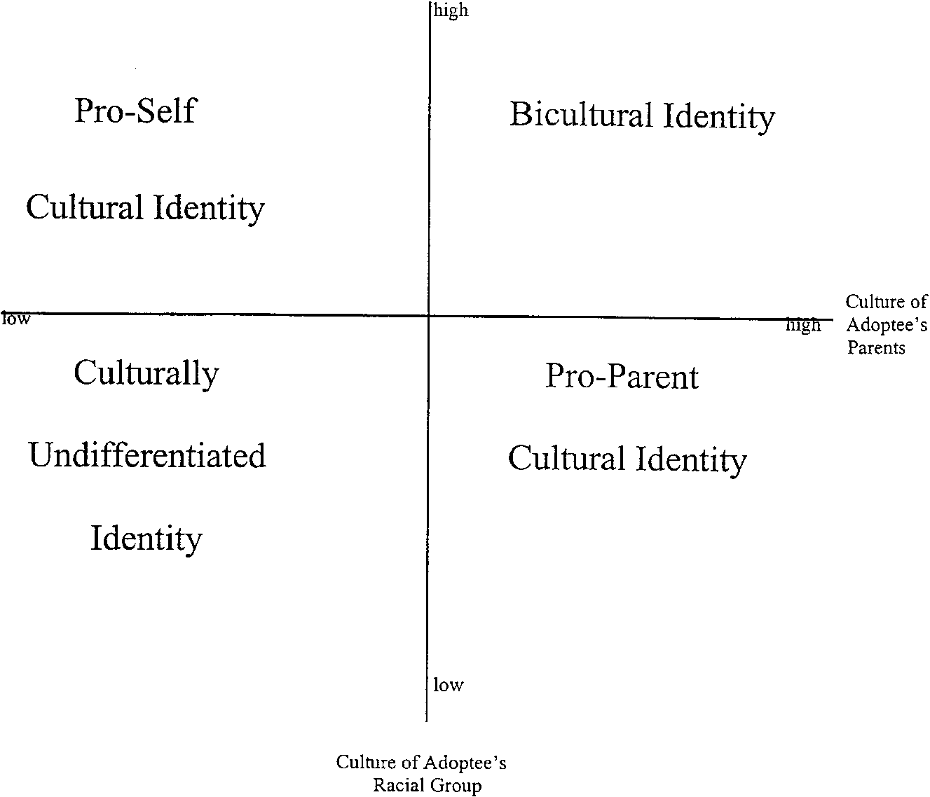
Fig. 1. The cultural identity axis.

exist each differing according to level of the transracial adoptee on each of the two dimensions. For example, transracial adoptees identifying more highly with their adoptive parents’ racial groups’ culture (i.e., the White culture) would be high on Parental Culture Dimension and low on Adoptees’ Culture Dimension; thus, the adoptees would have Pro-Parent Cultural Identities. Transracial adoptees who identify with the culture traditionally associated with their birth culture and who simultaneously feel less comfortable with the culture of their adoptive parents would be low on Parental Culture Dimension and high on Adoptees’ Culture Dimension; thus, they would have Pro-Self Cultural Identities. A graphic representation of the Cultural Identity Axis is depicted in Fig. 1.
In transracially adopting families, racial differences also exist among family members. Steward and Baden (1995) viewed these differences as affecting both racial/ethnic self-identification and the allegiances and friendships of transracial adoptees. Using a biosocial definition of race similar to that of Helms (1990), Steward and Baden (1995) considered racial groups to be determined by groups who are distinguished or consider themselves to be distinguished from other people by their physical characteristics and by their social relations with other people. As Brown (1995) and Phinney and Rosenthal (1992) described when discussing nonadopted or biracial individuals, transracial adoptees may make decisions about their racial group membership based on societal pressures (Brown, 1995) and the degree to which they have an achieved ethnic identity (Phinney & Rosenthal, 1992). Moreover, decisions about personal identity and situational identities (Richards, 1994) may be made as a result of the transracial adoption. Phinney and Rosenthal (1992) and Tizard and Phoenix (1994) noted that the ethnic self-identification of individuals can result in “misidentifying” one’s racial ethnic group membership. To account for varying racial ethnic self-identifications of transracial adoptees and for the role of allegiances and friendships in transracial adoptees experiences, Steward and Baden developed the Racial Identity Axis in the Cultural-Racial Identity Model.

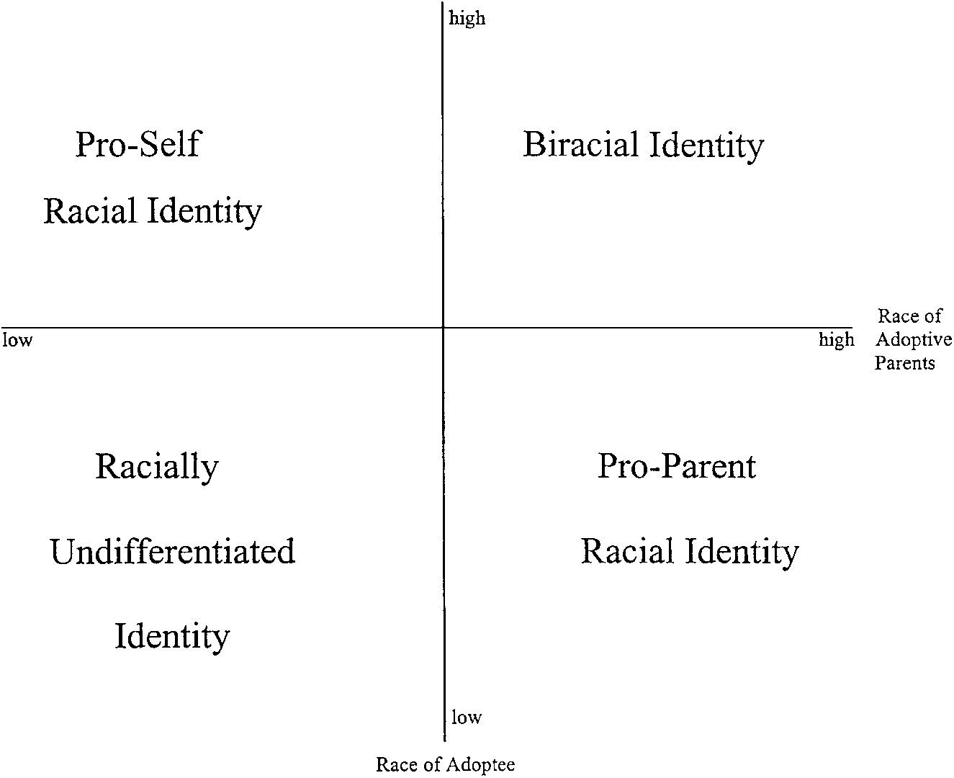
Fig. 2. The racial identity axis.

The Racial Identity Axis has two dimensions:

- Adoptee Race Dimension—the degree to which transracial adoptees identify with their own racial group (i.e., if the adoptee is Black, to what degree does the adoptee identify with Blacks).
- Parental Race Dimension—the degree to which transracial adoptees identify with their adoptive parents’ racial group (i.e., because most transracially adopting parents are White, to what degree does the adoptee identify with Whites).
The transracial adoptees’ levels of identification with a racial group is determined by assessing the degree to which the adoptees self-identify as belonging to their own racial group or their parents’ racial group. It also consists of the adoptees’ comfort level with people belonging to their own racial group and their adoptive parents’ racial group. The transracial adoptees’ comfort level with different racial groups involves their allegiances to those racial groups and the friendships they have with members belonging to different racial groups. In other words, these racial identities are determined according to the degree to which transracial adoptees accurately identify and are comfortable with their racial group membership and to which they are comfortable with either or both those of their racial group, their parents’ racial group, or multiple racial groups. Four possible racial identities are possible. These racial identities are Biracial Identity, Pro-Self Racial Identity, Pro-Parent Racial Identity, and Racially Undifferentiated Identity (see Fig. 2).
The final model combines the Cultural Identity Axis and the Racial Identity Axis into a single model. The Cultural-Racial Identity Model represents the pairing of each of the four types of possible cultural identities, as in Fig. 1, with each of the four types of possible racial identities, as in Fig. 2. The resulting model has 16 identity statuses to describe the identities of transracial adoptees. These identity statuses can be seen in the Fig. 3.
To better describe how transracial adoptees develop characteristics of each of the 16 cultural-racial identities and what may impact transracial adoptees’ progression through and entrance into each of the identities, descriptions of environmental or contextual factors likely to affect the identities of transracial adoptees were formulated (see Fig. 4).
In addition to the description of each of the potential cultural-racial identities that can exist in the population, a better understanding was need of the role that transracial adoptees’ adoptive parents, extended families, and the environment in which they were reared all play in transracial adoptees’ cultural-racial identities was needed. Baden and Steward (1997) attempted to demonstrate, through a theoretical and graphical representation, the contextual and familial situations, attitudes, and characteristics that would

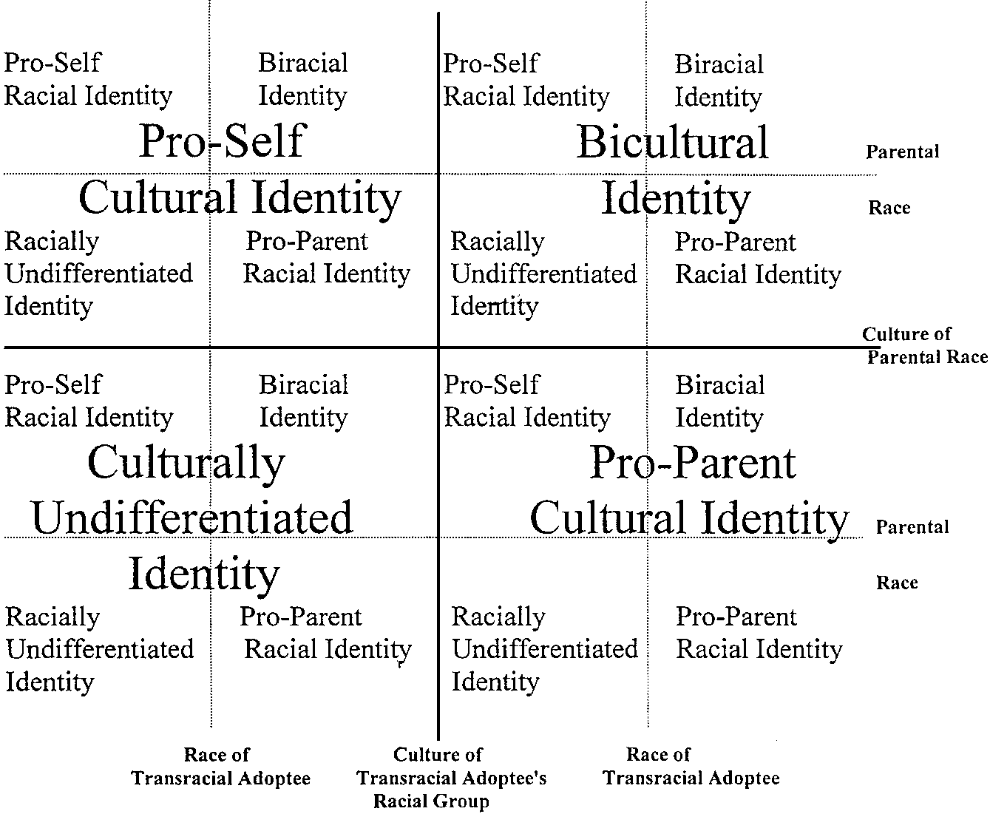

Fig. 3. The cultural-racial identity axis

produce transracial adoptees from each of the 16 potential cultural-racial identities in the Cultural-Racial Identity Model.

Pro-Self Cultural Identity—Pro-Self Racial Identity  High in knowledge, awareness, competence, and comfort in the culture of their own racial ethnic group and feel most comfortable with individuals of own racial ethnic group. May have been raised in a neighborhood in which the adoptees’ racial group’s culture predominated. May have rejected their adoptive parents’ culture and may feel like an outsider in their parents’ culture because of negative experiences in their parents’ culture or because of perceived pressure from members of their own racial ethnic group. | Pro-Self Cultural Identity—Biracial Identity  High in knowledge, awareness, competence, and comfort in the culture of their own racial ethnic group and feel most comfortable with individuals of either own racial ethnic group or parents’ racial ethnic group. May have been raised in a neighborhood in which the adoptees’ racial group’s culture predominated but were exposed to many members of their parents’ racial group and role models from both their own racial group and their parents’ racial group. | Bicultural—Pro-Self Racial Identity  High in knowledge, awareness, competence, and comfort in the cultures of both their own and their parents’ racial ethnic groups and feel most comfortable with individuals of their own racial ethnic group. May have been raised in a neighborhood in which both the adoptees and the parents’ racial groups’ culture predominated. Although competent and knowledgeable in birth and adoptive parents’ cultures, may prefer to associate with individuals from own racial group because of real, perceived, or developmental pressures from members of their own racial ethnic group and because of discomfort with individuals from other racial groups, particularly the dominant White racial group. | Bicultural—Biracial Identity  High in knowledge, awareness, competence, and comfort in the culture of both their own and their parents’ racial ethnic groups and feel most comfortable with individuals of either their own racial ethnic group or their parents’ racial ethnic group. May have been raised in a neighborhood in which both the adoptees and the parents’ racial groups’ culture predominated and were exposed to many members of their parents’ racial group and role mod- els from both their own racial group and their parents’ racial group.
Pro-Self Cultural Identity—Racially Undifferentiated Identity  High in knowledge, awareness, competence, and comfort in the culture of their own racial ethnic group and feel most comfortable with individuals of multiple racial ethnic groups. May have been raised in a neighborhood in which the adoptees’ racial group’s culture predominated. May have been exposed to members of multiple racial ethnic groups and to role models from multiple racial ethnic groups. A “human” identity may have been endorsed by parents. | Pro-Self Cultural Identity—Pro-Parent Racial Identity  High in knowledge, awareness, competence, and comfort in the culture of their own racial ethnic group and feel most comfort- able with individuals of their parents’ racial ethnic group. May have been raised in a neighborhood in which the adoptees’ racial group’s culture predominated. May not be visibly racially different from their adoptive parents’ appearance and / or may have had negative experiences with individuals of their own racial ethnic group (e.g., perceived rejection because of visible differences or because of transracial adoption status). May have been exposed to members and/or roles models of their parents’ racial ethnic group. | Bicultural—Racially Undifferentiated Identity  High in knowledge, awareness, competence, and comfort in the culture of both their own and their parents’ racial ethnic groups and feel most comfortable with individuals of multiple racial ethnic groups. May have been raised in a neighborhood in which both the adoptees and the parents’ racial groups’ culture predominated. May have been exposed to members of multiple racial ethnic groups and to role models from multiple racial ethnic groups. A “human” identity may have been endorsed by parents. | Bicultural—Pro-Parent Racial Identity  High in knowledge, awareness, competence, and comfort in the culture of both their own and their parents’ racial ethnic groups and feel most comfortable with individuals of their parents’ racial ethnic group. May have been raised in a neighborhood in which both the adoptees and the parents’ racial groups’ culture predominated. May not be visibly racially different from their adoptive parents’ appearance and / or may have had negative experiences with individuals of their own racial ethnic group (e.g., perceived rejection be- cause of visible differences or because of transracial adoption status). May have been exposed to members and/or roles models of their parents’ racial ethnic group.
Culturally Undifferentiated—Pro-Self Racial Identity  Not affiliated primarily with either their own or their parents’ racial ethnic groups’ cultures. Instead, they are high in their knowledge, awareness, competence, and comfort in multiple cultures including their own and their parents’ racial ethnic groups as well as other racial ethnic groups. Feel most comfortable with individuals of their own racial ethnic group. May have been raised in a neighborhood in which multiple racial groups’ cultures were represented. May have been exposed primarily to members of the adoptees’ racial ethnic groups and to role models from the adoptees’ racial ethnic group. May have rejected their adoptive parents’ culture and may feel like an outsider in their parents’ culture due to negative experiences in their parents’ culture or due to perceived pressure from members of their own racial ethnic group. | Culturally Undifferentiated—Biracial Identity  Not affiliated primarily with either their own or their parents’ racial ethnic groups’ cultures. Instead, they are high in their knowledge, awareness, competence, and comfort in multiple cultures including their own and their parents’ racial ethnic groups as well as other racial ethnic groups. Feel most comfortable with individuals of both their own and their parents’ racial ethnic groups. May have been raised in a neighborhood in which multiple racial groups’ cultures were represented. May have been exposed primarily to members of both the adoptees and the parents’ racial ethnic groups and to role models from both of those groups. | Pro-Parent Cultural Identity—Pro-Self Racial Identity  High in knowledge, awareness, competence, and comfort in the culture of their parents’ racial ethnic group but feel most comfortable with individuals of their own racial ethnic group. May have been raised in a neighborhood in which the parents’ racial group’s culture predominated. May have rejected their adoptive parents’ culture and may feel like an outsider in their parents’ culture because of negative experiences in their parents’ culture or because of perceived pressure from members of their own racial ethnic group. | Pro-Parent Cultural Identity—Biracial Identity  High in knowledge, awareness, competence, and comfort in the culture of their parents’ racial ethnic group and feel most comfortable with individuals of either their own racial ethnic group or their parents’ racial ethnic group. May have been raised in a neighborhood in which the parents’ racial group’s culture predominated. Were exposed to many members of their parents’ racial group and role models from both their own racial group and their parents’ racial group.
Culturally Undifferentiated—Racially Undifferentiated Identity  Not affiliated primarily with either their own or their parents’ racial ethnic groups’ cultures. Instead, they are high in their knowledge, awareness, competence, and comfort in multiple cultures including their own and their parents’ racial ethnic groups as well as other racial ethnic groups. Feel most comfortable with individuals of multiple racial ethnic groups. May have been raised in a neighborhood in which multiple racial groups’ cultures were represented. May have been exposed to members of multiple racial ethnic groups and to role models from multiple racial ethnic groups. A “human” identity may have been endorsed by parents. | Culturally Undifferentiated—Pro-Parent Racial Identity  Not affiliated primarily with either their own or their parents’ racial ethnic groups’ cultures. Instead, they are high in their knowledge, awareness, competence, and comfort in multiple cultures including their own and their parents’ racial ethnic groups as well as other racial ethnic groups. Feel most comfortable with individuals of their parents’ racial ethnic group. May have been raised in a neighborhood in which multiple racial group’s cultures were represented. May not be visibly racially different from their adoptive parents’ appearance and / or may have had negative experiences with individuals of their own racial ethnic group (e.g., perceived rejection because of visible differences or because of transracial adoption status). May have been exposed to members and/or roles models of their parents’ racial ethnic group. | Pro-Parent Cultural Identity—Racially Undifferentiated Identity  High in knowledge, awareness, competence, and comfort in the culture of their parents’ racial ethnic group and feel most comfortable with individuals of multiple racial ethnic groups. May have been raised in a neighborhood in which the adoptees’ racial group’s culture predominated. May have been ex- posed to members of multiple racial ethnic groups and to role models from multiple racial ethnic groups. A “human” identity may have been endorsed by parents. | Pro-Parent Cultural Identity—Pro-Parent Racial Identity  High in knowledge, awareness, competence, and comfort in the culture of their parents’ racial ethnic group and feel most comfortable with individuals of their parents’ racial ethnic group. May have been raised in a neighborhood in which the parents’ racial group’s culture predominated. May not be visibly racially different from their adoptive parents’ appearance and / or may have had negative experiences with individuals of their own racial ethnic group (e.g., perceived rejection because of visible differences or because of transracial adoption status). May have been exposed to members and/or roles models of their parents’ racial ethnic group.

Fig. 4. Depictions of the 16 cells of the cultural-racial identity model

Baden and Steward (1997) identified a factor that encompassed the potential attitudes and characteristics that parents may have toward their adoptive children and the potential effects that those attitudes may have on transracial adoptees’ identity statuses and psychological adjustment. The delineation of this factor was based upon the common themes in the theoretical literature regarding the importance of parental attitudes about the transracial adoptees’ racial group membership, the parents’ own reasons for deciding to adopt, the nurturing qualities and responsiveness of the parents, the immediate and extended familial attitudes, and the racial and cultural composition of the community and schools (e.g., Brenner, 1993; Alstein, Coster, First-Hartling, Ford, Glasoe, Hairston, Kasoff, & Wellborn Grier, 1994).
Baden and Steward (1997) posited that “parental attitudes and beliefs that either affirm or discount the transracial adoptees’ culture and racial group membership” (p. 10) would influence the development of the various cultural-racial identities. This addition to the Cultural-Racial Identity Model suggests that the degree to which parents, extended family, and the environment affirm (i.e., acknowledge, accept, approve of) the transracial adoptees’ racial group membership and/or their racial group’s culture will impact their identity and psychological adjustment. Similarly, discounting (i.e., decreased emphasis, lack of interest in, lack of acceptance of) the transracial adoptees’ racial group membership and/or their racial group’s culture will be likely to affect their identity and adjustment.
Baden and Steward (1997) created a graphic representation or a model to aid in understanding the factors at work (see Fig. 5). In the model, transracial adoptees may be reared in environments that:

- either affirm or discount the adoptive parents’ culture and/or racial group membership;
- either affirm or discount the transracial adoptees’ racial group’s culture and/or their racial group membership; or
- havesomecombinationofaffirmationanddiscountingofadoptiveparents’ and transracial adoptees’ cultures and racial groups.

Baden and Steward (1997) noted that the attitudes and characteristics they described were not expected to be explicit/intentional efforts, behaviors, beliefs, etc., nor are they necessarily resultant from inadvertent or unintentional efforts, behaviors, beliefs, etc. Rather than attempting to predict how active or passive adoptive parents may be in the transmission of these attitudes to transracial adoptees, the

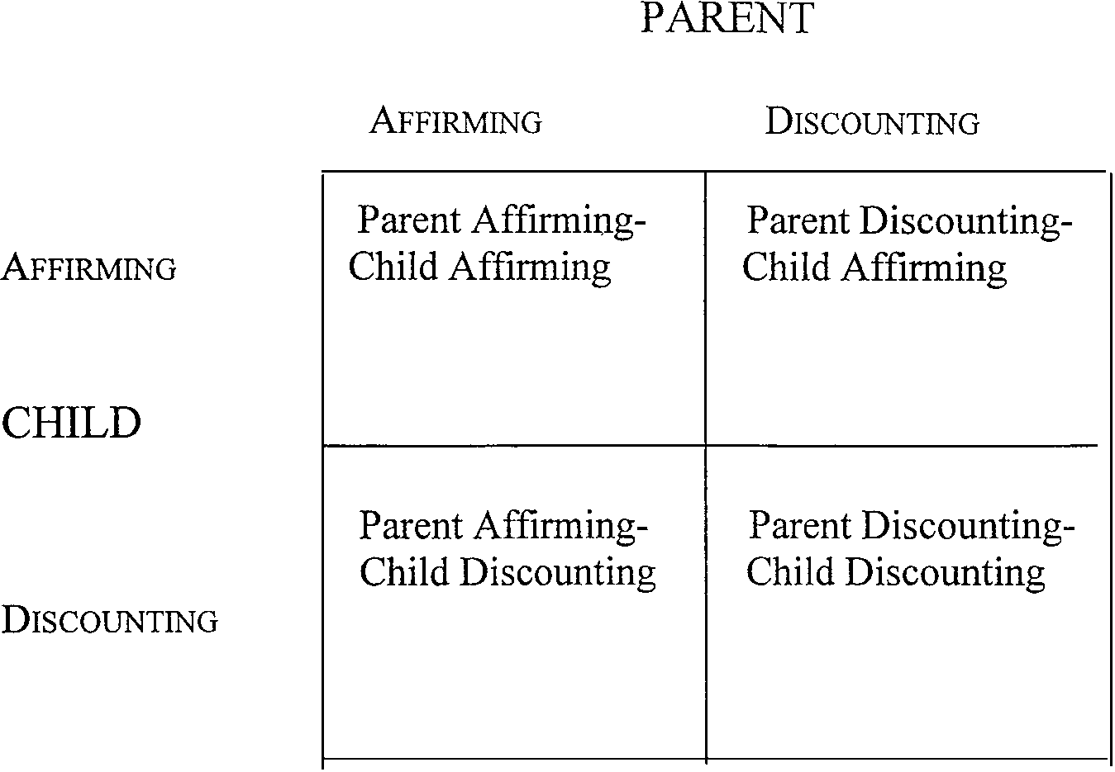
Fig. 5. Parental attitudes and characteristics model for affirming/discounting environments.

authors instead caution that the child-rearing context (including extended family, schools, teachers, community leaders, and peers) may also provide sources aiding in creating the contexts seen in Fig. 5.
The following model is based on parental attitudes and beliefs that either affirm or discount the transracial adoptees’ culture and racial group membership. That is, parental affirmation of their adopted child’s racial group membership will be likely to affect the adoptee’s identity status and the adoptee’s psychological adjustment. Furthermore, a parental attitude that discounts the adoptee’s racial group membership is also likely to affect identity and adjustment. In addition to attitudes about racial group membership, the quality and extent to which transracial adoptees engage in the cultural practices associated with their birth culture (i.e., the culture of their racial group) may likely be affected by an affirming or discounting environment. Affirmation refers to the acknowledgment, acceptance, and approval of the adoptee’s racial group membership and culture and the support of the adoptee’s identification with that racial group and/or culture. Discounting refers to a decreased emphasis on racial group membership and culture that may be demonstrated by a lack of interest in or acceptance of the racial group and/or culture. The attitudes and characteristics to be described refer to a result of environmental and familial factors.
As noted above, the attitudes and characteristics that lead to an affirming or discounting environment may be explicit, intentional, active efforts or they
may be inadvertent, unintentional, passive messages. For example, parents may intentionally or inadvertently promote or expose transracial adoptees to attitudes and contexts that are prejudiced toward or discriminatory toward the adoptees’ racial and/or cultural groups. In this case, the context in which the adoptees are reared may affirm the parents’ racial and cultural groups and discount the adoptees’ racial and cultural groups. Furthermore, although parents serve as the primary source for conveying attitudes and for creating the child-rearing context, transracial adoptees may also be impacted by other aspects of their context. For example, schools, teachers, community leaders, and peers may contribute to the creation of the contexts to be described. Although this model does not account for the degree of intentionality of the attitudes and resulting contexts that adoptive parents provide, the degree of intentionality is an area to which clinical attention should be paid.
Transracial adoptees raised in a parent affirming-child affirming context are likely to have been exposed to positive or healthy role models phenotypically resembling the transracial adoptees’ parents and the adoptees themselves. The environment contains images, attitudes, role models, friends, and extended family who are affirming and supportive of the adoptive parents’ racial and cultural groups and of the transracial adoptees’ racial and cultural groups. The predominant attitude in this category is acceptance of both racial and cultural groups. A potential drawback to this attitude is the possibility of denial of the racial climate and the conflicts regarding race and culture in this country.
A parent discounting-child affirming context is likely to result when the adoptive parents focus on the racial group and culture of the transracial adoptees to the extent that they may disregard or neglect to account for their own racial and cultural group. The role models to whom the transracial adoptees have been exposed may result in the approval of the transracial adoptees’ racial group and the culture of their racial group. With or without intending to do so, the adoptive parents may minimize the role of those of their racial and/or cultural group to the adoptees. The parents may be preoccupied with the transracial adoptees’ racial and cultural group to the exclusion of the parents’ racial and cultural group. In this case, adoptive parents may minimize or fail to account for the power and impact of those of their own racial and cultural group in their environment. The adoptees may be exposed to positive role models from the transracial adoptees’ racial group but negative or poor role models from the adoptive parents’ racial group. This may occur through school, peers, family, and so on. The predominant attitude shown is acceptance and approval of the transracial adoptees’ racial group and the culture of their racial group and discounting or minimization of the adoptive parents’ racial group. The drawback to this attitude may be in the failure to acknowledge and present positive role models from the dominant race and culture so that the adoptee may engage in a dichotomous belief system about race and may assume discrimination and oppression when there is none.
A parent affirming-child discounting context may be the result of adoptive parents who are preoccupied and focused on their own racial and cultural group to such a degree that they may disregard that of the transracial adoptees. Positive role models for the adoptees may tend to represent the parental racial and cultural group without equal or similar attention given to role models from the transracial adoptees’ racial and cultural groups. The adoptive parents may have little interaction with and/or knowledge of the transracial adoptees’ racial group and the culture of the racial group, thus resulting in an exposure bias toward their own racial and cultural group. The predominant attitude may be acceptance and approval of the parental culture without attention or exposure to the role of the transracial adoptees’ racial group membership and the culture of their racial group. This attitude may impede the transracial adoptee by failing to recognize, affirm, and accept individuals physically similar to the adoptee. Although this may be unintentional, it may convey a disrespect for or dislike for those similar to the adoptee and may cause and identity confusion that is difficult to resolve. Again, a dichotomous belief system is likely to result.
Transracial adoptees reared in a parent discounting-child discounting environment may endorse a “human race” or a “color blind” society and attitude as healthiest, so the adoptive parents may not attend to the racial and cultural groups of both the parents and the transracial adoptees. Instead, they endorse a disposition attesting to the equality of all races without attention to or preference for any in particular. Positive role models may be from multiple racial groups including parental and adoptees’ racial and cultural groups, but when exposure to the role models occurs, the race and culture of the role models may not be addressed and attributions for success and health may be made to other characteristics or attitudes. The predominant attitude could be one of attributing importance, power, success, and happiness to individual characteristics not based on race or culture. This attitude has considerable appeal, but the danger may be similar to that found in the parent affirming-child affirming attitudes—denial. The parents and adoptees may be unrealistic about discrimination and oppression and fail to understand the dynamics in society based on racial and cultural group membership.
Other factors likely to have an impact on the cultural and racial identities of transracial adoptees are the attitudes and degree of emotional support of the community (schools, social agencies, teachers, peers) and extended family members, including grandparents, of the transracial adoptees. Finally, the support networks established by the adoptive parents may affect the adoptees. These factors will impact identity because of their status as alternative sources of feedback for adoptees and the level of influence they may exert on parental and adoptees’ attitudes and beliefs.
Conclusion
The Cultural-Racial Identity Model is the first theoretical model to separate cultural identity and racial identity. The implications for its use are vast and point to the need for the empirical validation of the model. Its use with the populations already identified in this paper must also be empirically validated.
Following empirical validation, the Cultural-Racial Identity Model will be a comprehensive framework for researchers to use with individuals raised in racially integrated families. The model can also serve as a guide for transracial adoptees and adoptive parents to better understand and guide their life experiences. Furthermore, psychotherapeutic practitioners can use the model as a guide for determining the counseling needs of those raised in racially integrated families, particularly as they differ from the needs of individuals raised in same race households. The information to be gleaned from the use of this model as a framework for research and practice will allow those from racially integrated families to be better served and for their unique experiences to be addressed appropriately and comprehensively.
The Cultural-Racial Identity Model represents an important step in addressing the needs of individuals who have multiple identities with which to describe themselves. The strength of the model is in its willingness to account for heterogeneity within groups that have previously been studied without respect for the uniqueness within these populations. With the information gleaned from the application of the Cultural-Racial Identity Model to groups such as transracial adoptees and biracial individuals, psychologists, social workers, adoption workers, and others in the helping professions will be better prepared to address the adjustment, identity, and esteem problems that have been of such concern to opponents and proponents of transracial adoption alike.
References
Alstein, H., Coster, M., First-Hartling, L., Ford, C., Glasoe, B., Hairston, S., Kasoff, J, & Wellborn Grier, A. W. (1994). Clinical observations of adult intercountry adoptees and their adoptive parents. Child Welfare, 73, 261–269.
Andujo, E. (1988). Ethnic identity of transethnically adopted Hispanic adolescents. Social Work, 33, 531–535.
Atkinson, D. R., Morten, G., & Sue, D. W. (1989). Counseling American minorities: A cross-cultural perspective (3rd ed.). Dubuque, Iowa: Brown.
Baden, A. L., & Steward, R. J. (1997, February). The role of parents and family in the psychological adjustment of transracial adoptees: Implications for the Cultural-Racial Identity Model for transracial adoptees. Paper presented at the meeting of the Fourteenth Annual Teachers College Roundtable on Cross-Cultural Psychology and Education.
Bagley, C. (1992). The psychology of adoption: Case studies of national and international adoptions. Bulletin of the Hong Kong Psychological Society, 28/29, 95–115.
Barth, R. P., Berry, M., Yoshikami, R., Goodfield, R. K., & Carson, M. L. (1988). Predicting adoption disruption. Social Work, 33, 227–233.
Brenner, E. M. (1993). Identity formation in the transracially-adopted adolescent (Doctoral dissertation, California School of Professional Psychology at Berkeley/Almeda, 1993). Dissertation Abstracts International, 54, 3871.
Brown, U. M. (1995). Black/White interracial young adults: Quest for a racial identity. American Journal of Orthopsychiatry, 65, 125–130.
Cross, W. E. (1971). The Negro-to-Black conversion experience: Toward a psychology of Black liberation. Black World, 20, 13–27.
Erikson, E. H. (1968). Identity Youth and Crisis. New York: W.W. Norton & Company, Inc.
Grow, L. J., & Shapiro, D. (1974). Black children-White parents. New York: Child Welfare League of America, Inc.
Helms, J. E. (Ed.). (1990). Black and White racial identity: Theory, research, and practice. New York: Greenwood Press.
Helwig, A. A., & Ruthven, D. H. (1990). Psychological ramifications of adoption and implications for counseling. Journal of Mental Health Counseling, 12, 24–37.
Hill, M., & Peltzer, J. (1982). A report of thirteen groups for White parents of Black children. Family Relations, 31, 557–565.
Hollingsworth, L. D. (1997). Effect of transracial/transethnic adoption on children’s racial and ethnic identity and self-esteem: A meta-analytic review. Marriage and Family Review, 25, 99–130.
Kim, S. P., Hong, S., & Kim, B. S. (1979). Adoption of Korean children by New York couples: A preliminary study. Child Welfare, 58, 419–427.
LeVine, E. S., & Sallee, A. L. (1990). Critical phases among adoptees and their families: Implications for therapy. Child and Adolescent Social Work, 7, 217–232.
Loenen, A., & Hoksbergen, R. (1986). Inter-country adoption: The Netherlands: Attachment relations and identity. Adoption & Fostering, 10, 22–26.
Marcia, J. E. (1980). Identity in adolescence. In J. Adelson (Ed.), Handbook of adolescent psychology (pp. 159–187). New York: John Wiley & Sons.
McRoy, R. G. (1989). An organizational dilemma: The case of transracial adoptions. The Journal of Applied Behavioral Science, 25, 145–160.
McRoy, R. G., Zurcher, L. A., Lauderdale, M. L., & Anderson, R. E. (1982). Self-esteem and racial identity in transracial and intraracial adoptees. Social Work, 27, 522–526.
McRoy, R. G., Zurcher, L. A., Lauderdale, M. L., & Anderson, R. E. (1984). The identity of transracial adoptees. Social Casework, 65, 34–39.
Myer, R., & James, R. K. (1989). Counseling internationally adopted children: A personal intervention approach. Elementary School Guidance & Counseling, 23, 324–328.
National Association of Black Social Workers. (September, 1972). NABSW opposes transracial adoption. New York: National Association of Black Social Workers.
Norvell, M., & Guy, R. F. (1977). A comparison of self-concept in adopted and non-adopted adolescents. Adolescence, 52, 443–448.
Patterson, S. J., Sochting, I., & Marcia, J. E. (1992). In G. R. Adams, T. P. Gullotta, & R. Montemayor (Eds.). (1992) Adolescent identity formation (pp. 9–24). Newbury Park, CA: Sage Publications, Inc.
Phinney, J. S., Rosenthal, D. A. (1992). Ethnic identity in adolescence: Process, context, and outcome. In G. R. Adams, T. P.
Gullotta, & R. Montemayor (Eds.). (1992) Adolescent identity formation (pp. 145–172). Newbury Park, CA: Sage Publications, Inc.
Rathbun, C., & Kolodny, R. L. (1967). A groupwork approach in cross-cultural adoptions. Children, 14, 117–121.
Richards, B. (1994). What is identity? In I. Gaber & J. Aldridge (Eds.), In the best interests of the child: Culture, identity and transracial adoption. London: Free Association Books Ltd.
Rickard Liow, S. J. (1994). Transracial adoption: Questions on heritage for parents, children and counsellors. Counseling Psychology Quarterly, 7, 375–384.
Shireman, J. F., & Johnson, P. R. (1986). A longitudinal study of Black adoptions: Single parent, transracial, and traditional. Social Work, 31, 172–176.
Silverman, A. R., & Feigelman, W. (1981). The adjustment of Black children adopted by White families. Social Casework: The Journal of Contemporary Social Work, 62, 529–536.
Simon, R. J., & Alstein, H. (1977). Transracial adoption. New York: Wiley Interscience.
Simon, R. J., & Alstein, H. (1981). Transracial adoption: A follow-up. Lexington, MA: D.C. Heath and Company.
Steward, R. J., & Baden, A. L. (1995). The Cultural-Racial Identity Model: Understanding the racial identity and cultural identity development of transracial adoptees (Report No. UD030908). East Lansing, MI: Michigan State University. (ERIC Document Reproduction Service No. ED 39 50 76)
Tizard, B. (1991). Intercountry adoption: A review of the evidence. Journal of Child Psychology and Psychiatry, 32, 743–756.
Tizard, B., & Phoenix, A. (1994). Black identity and transracial adoption. In I. Gaber & J. Aldridge (Eds.), In the best interests of the child: Culture, identity and transracial adoption. London: Free Association Books Ltd.
Trolley, B. C. (1994–1995). Grief issues and positive aspects associated with international adoption. Omega, 30, 257–268.
Whaley, A. L. (1993). Self-esteem, cultural identity, and psychosocial adjustment in African American children. Journal of Black Psychology, 19, 406–422.
Zastrow, C. (1977). Outcome of Black children–White parent transracial adoptions. San Francisco: R and E Research Associates.

APA Reference for this paper:
Baden, A. L., & Steward, R. J. (2000). A framework for use with racially and culturally integrated families: The Cultural-Racial Identity Model as applied to transracial adoptees [Special Issue: Adoption]. Journal of Social Distress and the Homeless, 9, 309-337. https://doi.org/10.1023/A:1009493827019

